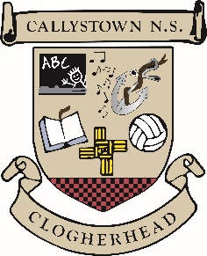

Callystown National School
ANNUAL ADMISSION NOTICE
In Respect of Admissions for the 2026/27 School Year
Special Classes for Autistic Students
A copy of the school’s Admissions Policy, Autism Class Enrolment policy and the Application Form for Admission to the Autism Classes for the school year 2025/26 is available as follows:
To download at: www.callystownnnationalschool.ie
On request: By emailing principal@callystownnationalschool.ie

Application & Decision Dates for Admission 2026/27 (ASD Class)
The following are the dates applicable for admission to the newly established ASD Class 2025/26:

The school will commence accepting applications for admission to the Autism Classes | Jan 5th 2026
The school will cease accepting applications for admission to the Autistic Classes | Mar 15^{5h}  2026
The date by which applicants will be notified of the decision on their application. | Mar 26th  2026
The period within which applicants must confirm acceptance of an offer of admission. | April 8th  2026

Please Note
- Failure to accept an offer within the prescribed period above may result in the offer being withdrawn.
- The school will consider and issue decisions on late applications in accordance with the school’s Enrolment Policy.
Number of places available in the ASD Classes in 2026/27
The number of places available for the 2024/25 school year is - | 2

