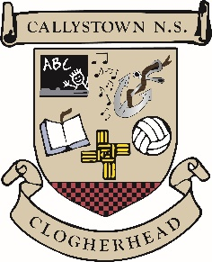

**Callystown National School**

**ANNUAL ADMISSION NOTICE**

**In Respect of Admissions for the 2025/26 School Year**

**Special Classes for Autistic Students**

A copy of the school’s **Admissions Policy, Autism Class Enrolment policy** and the **Application Form for Admission to the Autism Classes** for the school year 2025/26 is available as follows:

To download at: www.callystownnnationalschool.ie

On request: By emailing principal@callystownnationalschool.ie

**Application & Decision Dates for Admission 2025/26 (ASD Class)**

The following are the dates applicable for admission to the newly established ASD Class 2025/26:

|  |  |
| --- | --- |
| The school will commence accepting applications for admission to the Autism Classes | Feb 14th 2025 |
| The school will cease accepting applications for admission to the Autistic Classes | Mar 14th  2025 |
| The date by which applicants will be notified of the decision on their application. | Mar 24th  2025 |
| The period within which applicants must confirm acceptance of an offer of admission. | April 7th  2025 |

**Please Note**

* Failure to accept an offer within the prescribed period above may result in the offer being withdrawn.
* The school will consider and issue decisions on late applications in accordance with the school’s Enrolment Policy.

**Number of places available in the ASD Classes in 2025**

|  |  |
| --- | --- |
| The number of places available for the 2024/25 school year is - | **12** |